尋找賴瑞

Locate Larry

在這個專案，你會製作一個『尋找威利』(Where’s Wally?)的遊戲

In this project you will make a “Where’s Wally?” game (“Where’s Waldo?” if you’re from the US).

你會使用Scratch設計一個非常簡單的『威利風格』照片：在一個隨機選擇的背景上，把所有卡通角色通通打散隨意擺置。

You’ll use a Scratch project that generates very simple “Where’s Wally?” style pictures – mixing up cartoon characters on a random background.

你會使用這個Scratch專案訓練電腦從畫面上找出一個特定的角色

You’ll use the Scratch project to train the computer to be able to spot one of the characters in the scene.

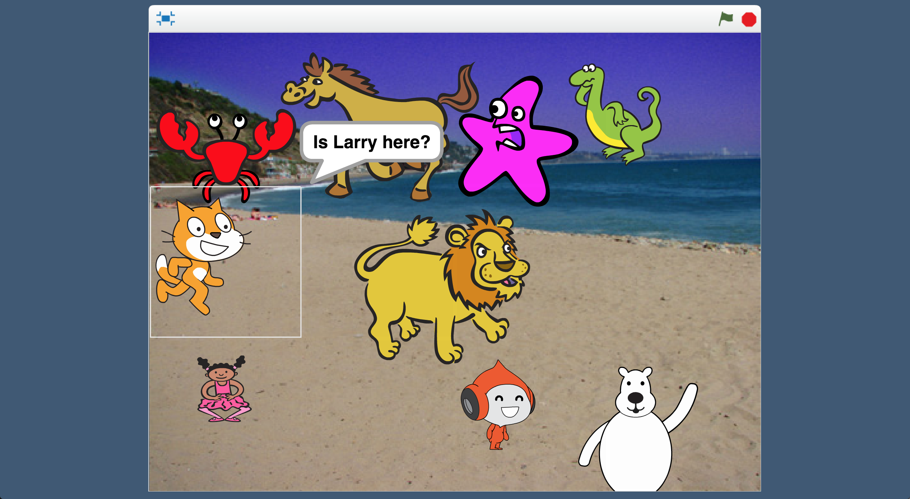

This project worksheet is licensed under a Creative Commons Attribution Non-Commercial Share-Alike License

http://creativecommons.org/licenses/by-nc-sa/4.0/

1. 從下方挑選一個角色

*這份學習單裡，我選擇Scratch貓咪，但你可以選擇自己喜歡的角色*

Choose **one** of these characters   
*In this worksheet, I’ll choose the Scratch Cat. But choose one that you like.*   
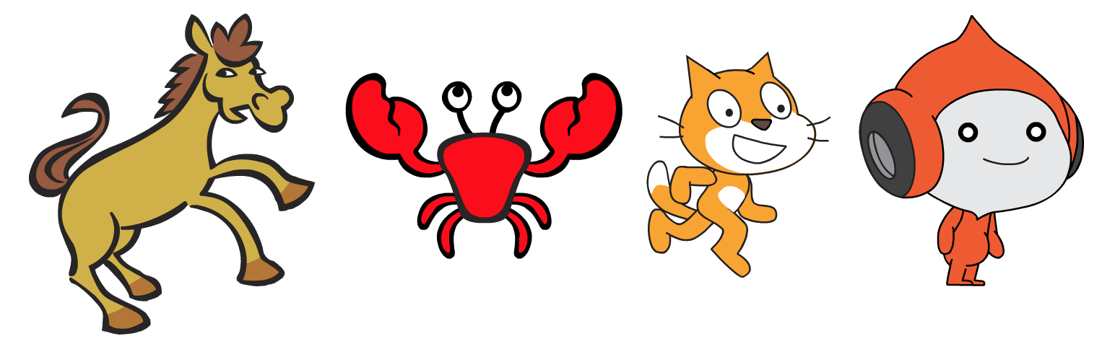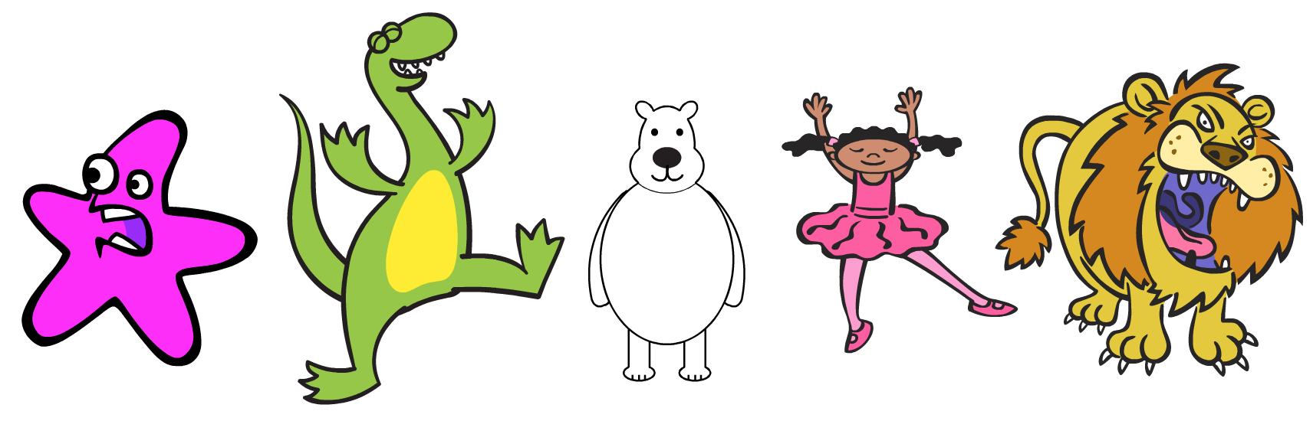

1. 幫你選的角色取一個名字

*這份學習單裡，我把角色命名為Larry，但同樣地，選擇一個你喜歡的名字*

Think of a name for the character you chose  
*In this worksheet, I’ll be using “Larry”. But come up with your own name.*

1. 搜尋網頁：<https://machinelearningforkids.co.uk/>

Go to <https://machinelearningforkids.co.uk/> in a web browser

1. 點選“**Get started**”按鈕

Click on “**Get started**”

1. 點選“**Log In**”按鈕並登入系統

*如果你沒有帳號，請你的老師幫你建立一個帳號。*

*如果你不記得你的帳號或密碼，請你的老師幫你重新設定一次。*

Click on “**Log In**” and type in your username and password  
*If you don’t have a username, ask your teacher or group leader to create one for you.  
If you can’t remember your username or password, ask your teacher or group leader to reset it for you.*

1. 點選上方清單中的 **”Projects”** 按鈕

Click on “**Projects**” on the top menu bar

1. 點選 “**+ Add a new project**” 按鈕

Click the **“+ Add a new project**” button.

1. 將你的專案命名為Locate Larry並設定成辨識 “**images**”類別，點

選 “**Create**”按鈕

Name your project “Locate Larry” and set it to learn how to recognise “**images**”. Click the “**Create**” button  
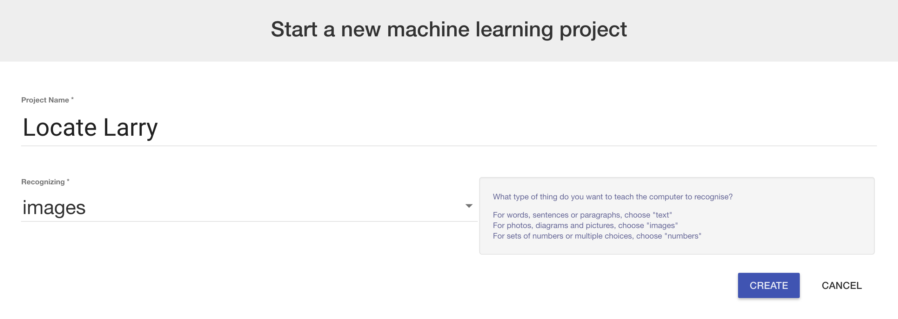

1. 你會在專案清單中看到**Locate Larry**，點選此專案

You should see “**Locate Larry**” in the list of your projects. Click on it.

1. 點選 **”Train”** 按鈕

Click the “**Train**” button  
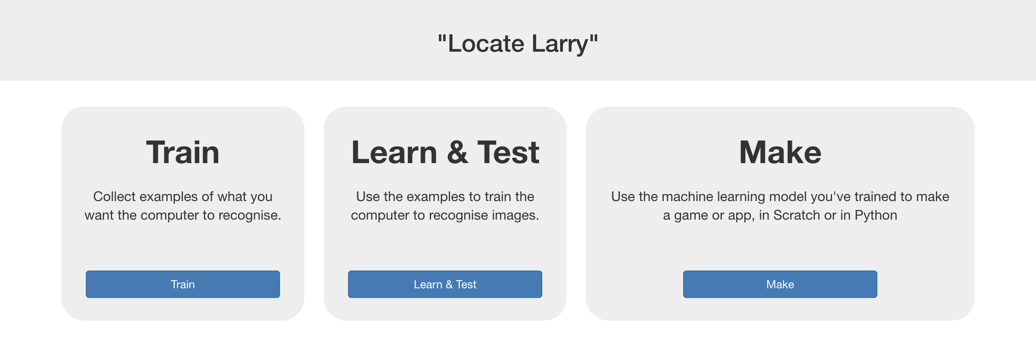

1. 點選 “**+ Add new label**”按鈕，新增一個以你選的角色名稱為名的標籤（例如：Larry）

Click the **“+ Add new label**” button. Create a label with the name you chose for your character. (e.g. “Larry”)

1. 點選 “**+ Add new label**”按鈕，新增一個標籤，命名格式為：Not 角色名稱（例如：Not Larry）

Click “**+ Add new label**” again. Create a label with the name   
“Not <Character Name>” (e.g. “Not Larry”)  
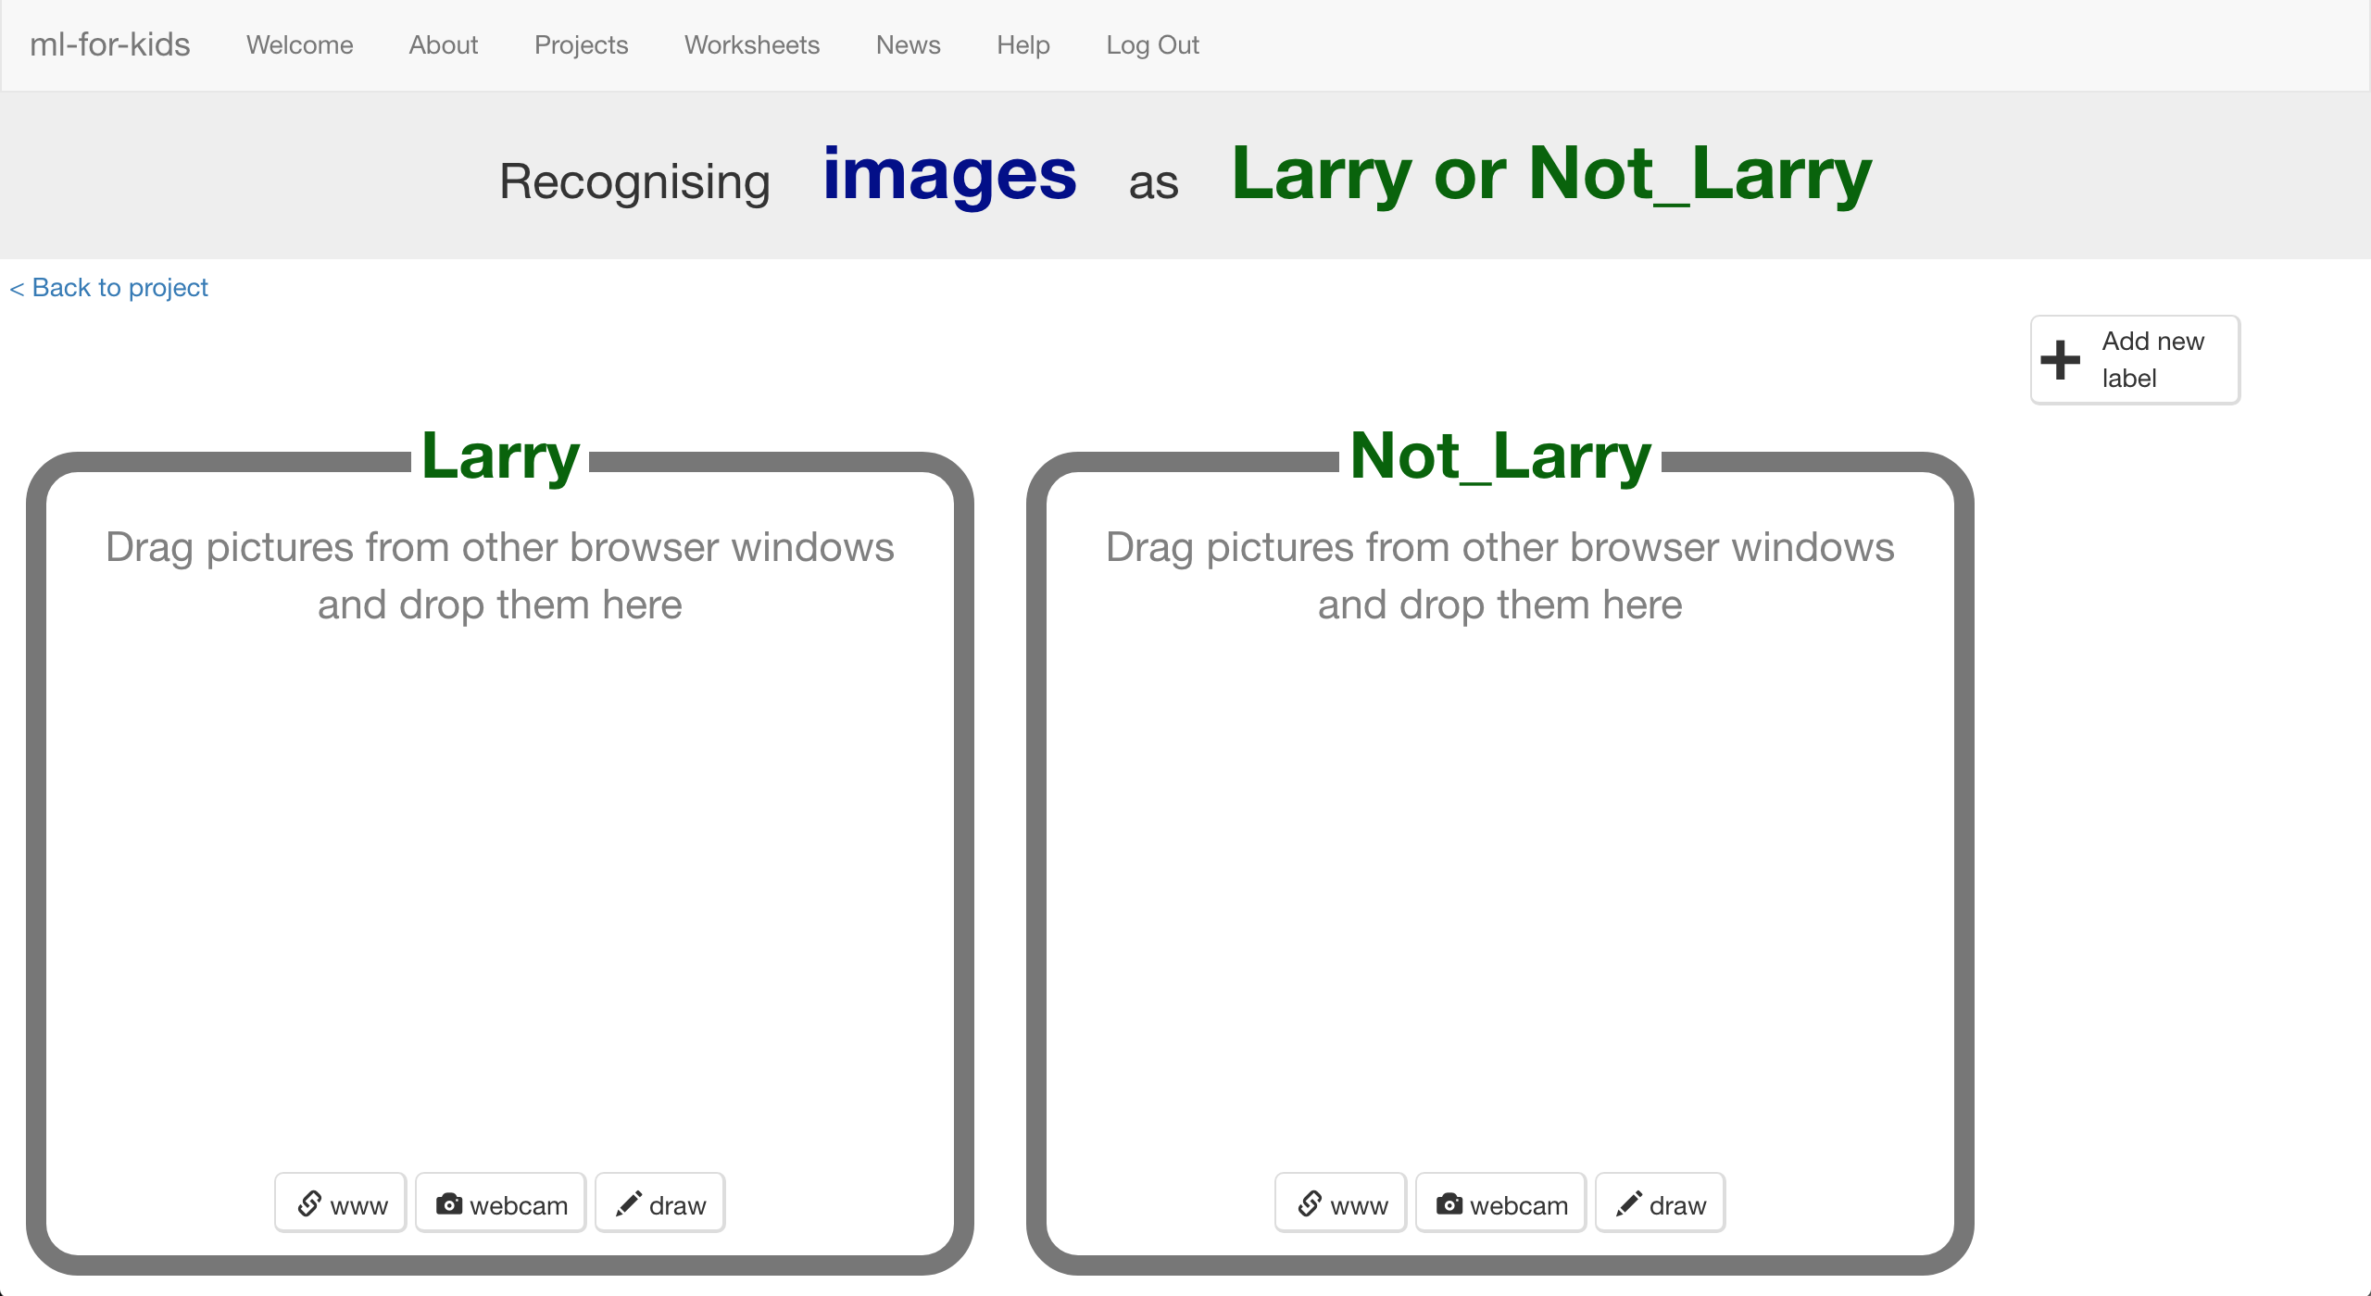

1. 點選“**< Back to project**”

Click the “**< Back to project**” link

1. 點選**Make**按鈕

Click the “**Make**” button

1. 點選**Scratch**按鈕

Click the “**Scratch**” button

1. 點選**straight into Scratch**按鈕

Click the “**straight into Scratch**” button  
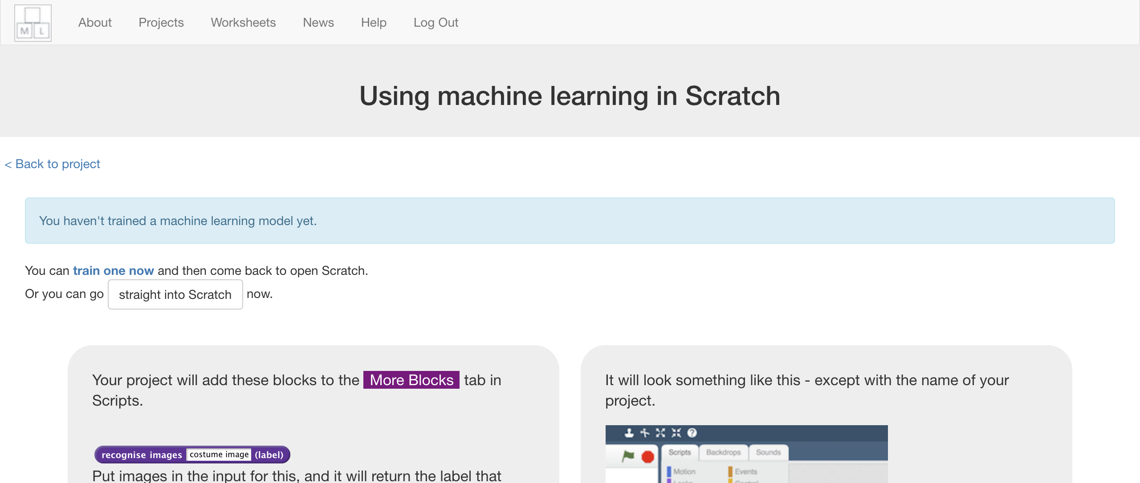

1. 你可以在專案裡的『更多積木』(More blocks)區看到新積木

*You should see new blocks in the “****More blocks****” section*  
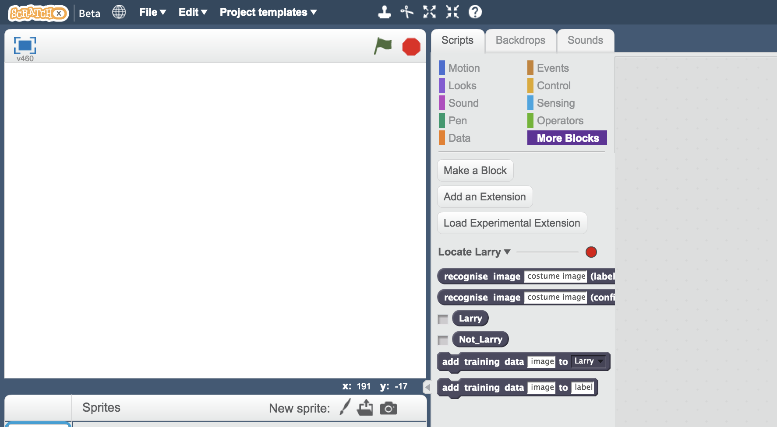

1. 開啟Locate Larry專案

點選***Project templates，***再點選***Locate Larry***

Open the Locate Larry project template  
*Click “****Project templates****” -> “****Locate Larry****”*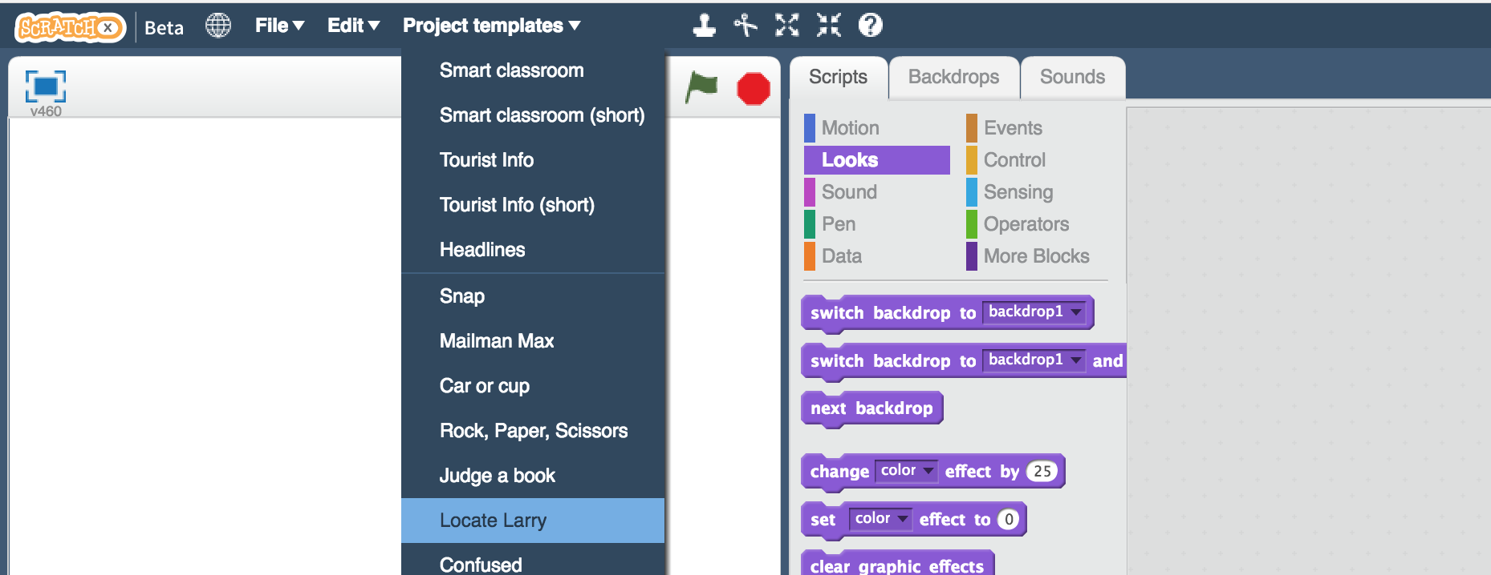

1. 點選角色**0,0**，找到積木組合區的**store HIT**積木

Click on the “**0,0**” sprite, and find the “**store HIT**” script  
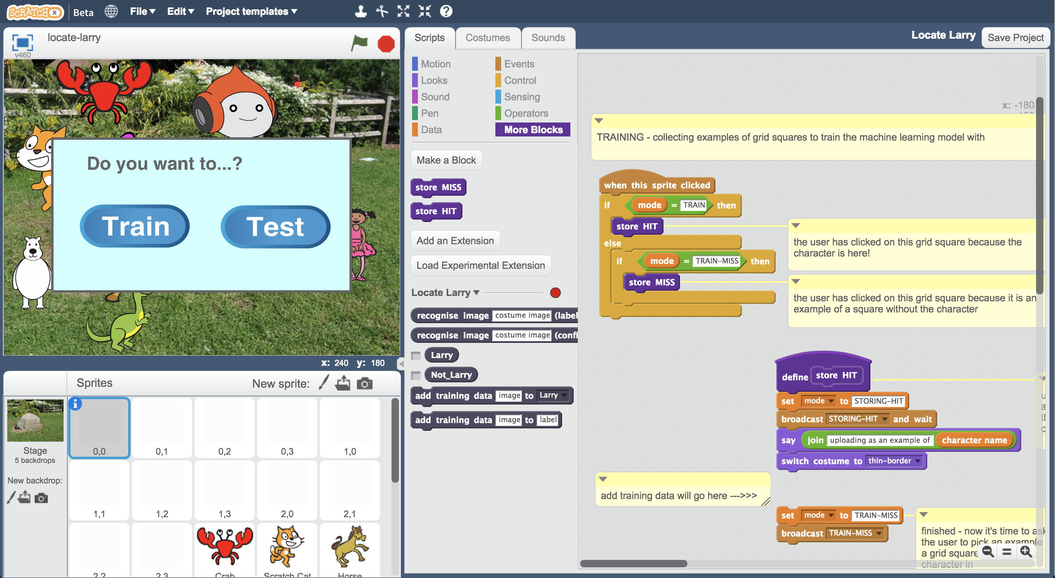

1. 寫著“add training data will go here”的註解是在提醒你：下一步你需要在這邊加入一個新積木

The “add training data will go here” comment is there to show you where you need to add a new block in the next step.   
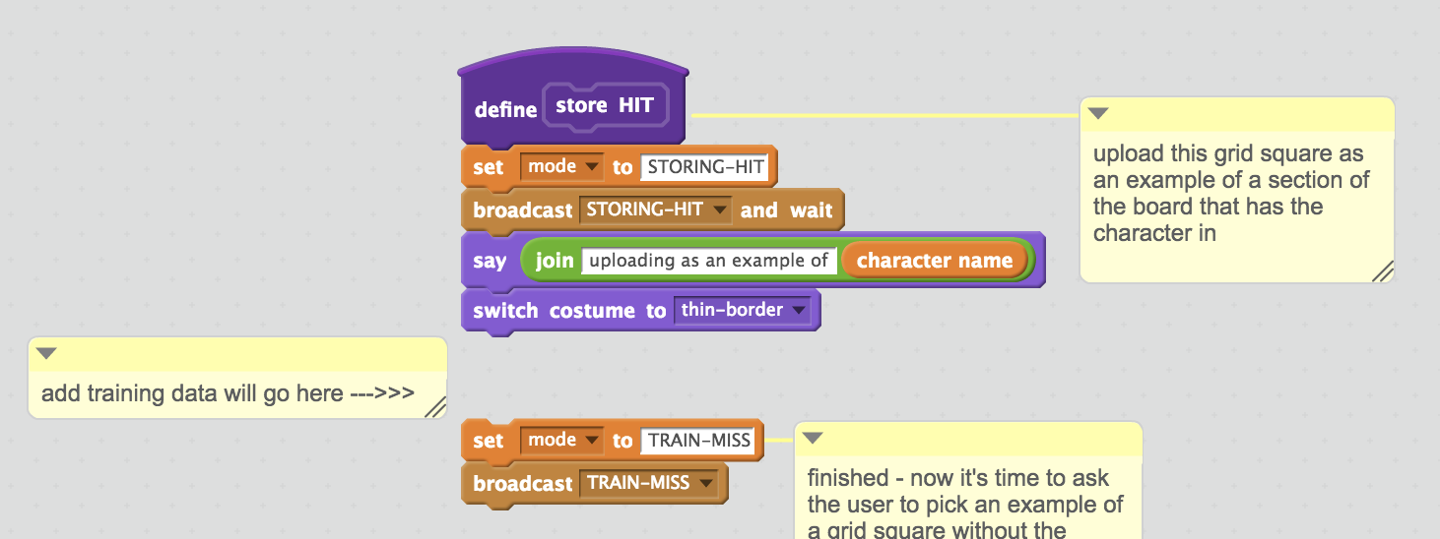

1. 拖曳**add training data**積木，和其他積木組合在一起（如下圖）

Add the “**add training data**” block and join it all up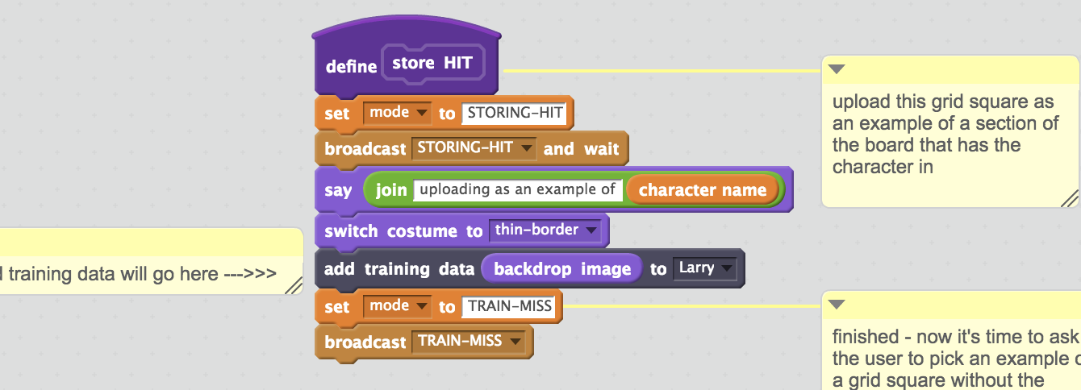

1. 找到積木組合區的**store MISS**積木

*這段積木應該在store HIT的下方*

Find the “**store MISS**” block script.   
*It should be just underneath “store HIT” – you might need to scroll down.*

1. 跟前面動作類似，在註解的地方加入**add training data**積木，但這一次要選擇Not Larry而不是Larry。

*Larry要換成你取的名字，並確認你有把積木都組合在一起。*

Put another “**add training data**” block where the comment is, like before. This time, you should use “Not Larry” instead of “Larry”  
*This will be the name you’ve chosen, not “Larry”.   
Make sure you join the script up again.*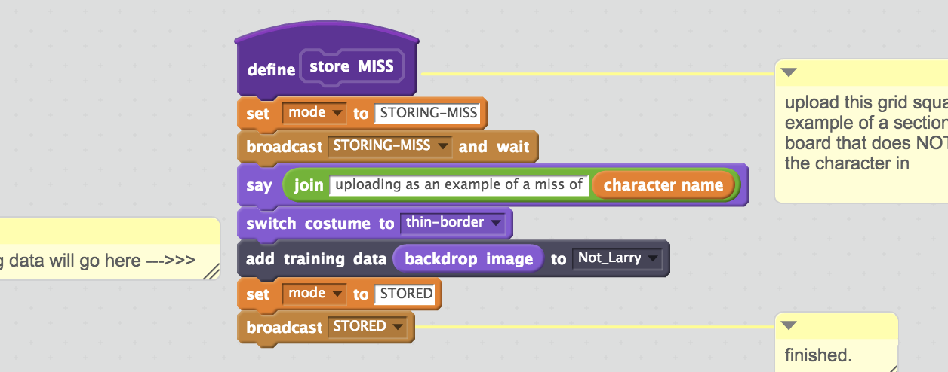

1. 角色0,1 0,2 0,3 1,0 1,1 1,2 1,3 2,0 2,1 2,2 2,3也都要做上述兩個動作（加上角色0,0共有12個角色）。

*記住：store* ***HIT****段落的積木要選擇“你的角色名稱”，而store* ***MISS****段落的積木要選擇“****Not*** *你的角色名稱”*

Do that again for all the other grid square sprites:  
0,1 0,2 0,3 1,0 1,1 1,2 1,3 2,0 2,1 2,2 2,3  
  
You need to do all twelve sprites that look like grey squares.  
 *Remember: choose “****Name”*** *of your character in “store* ***HIT****” and   
 choose “****Not******Name****” of your character in “store* ***MISS****”*

1. 點選『舞台』，輸入你的角色名稱

Click on “**Stage**” and type your character name in the script   
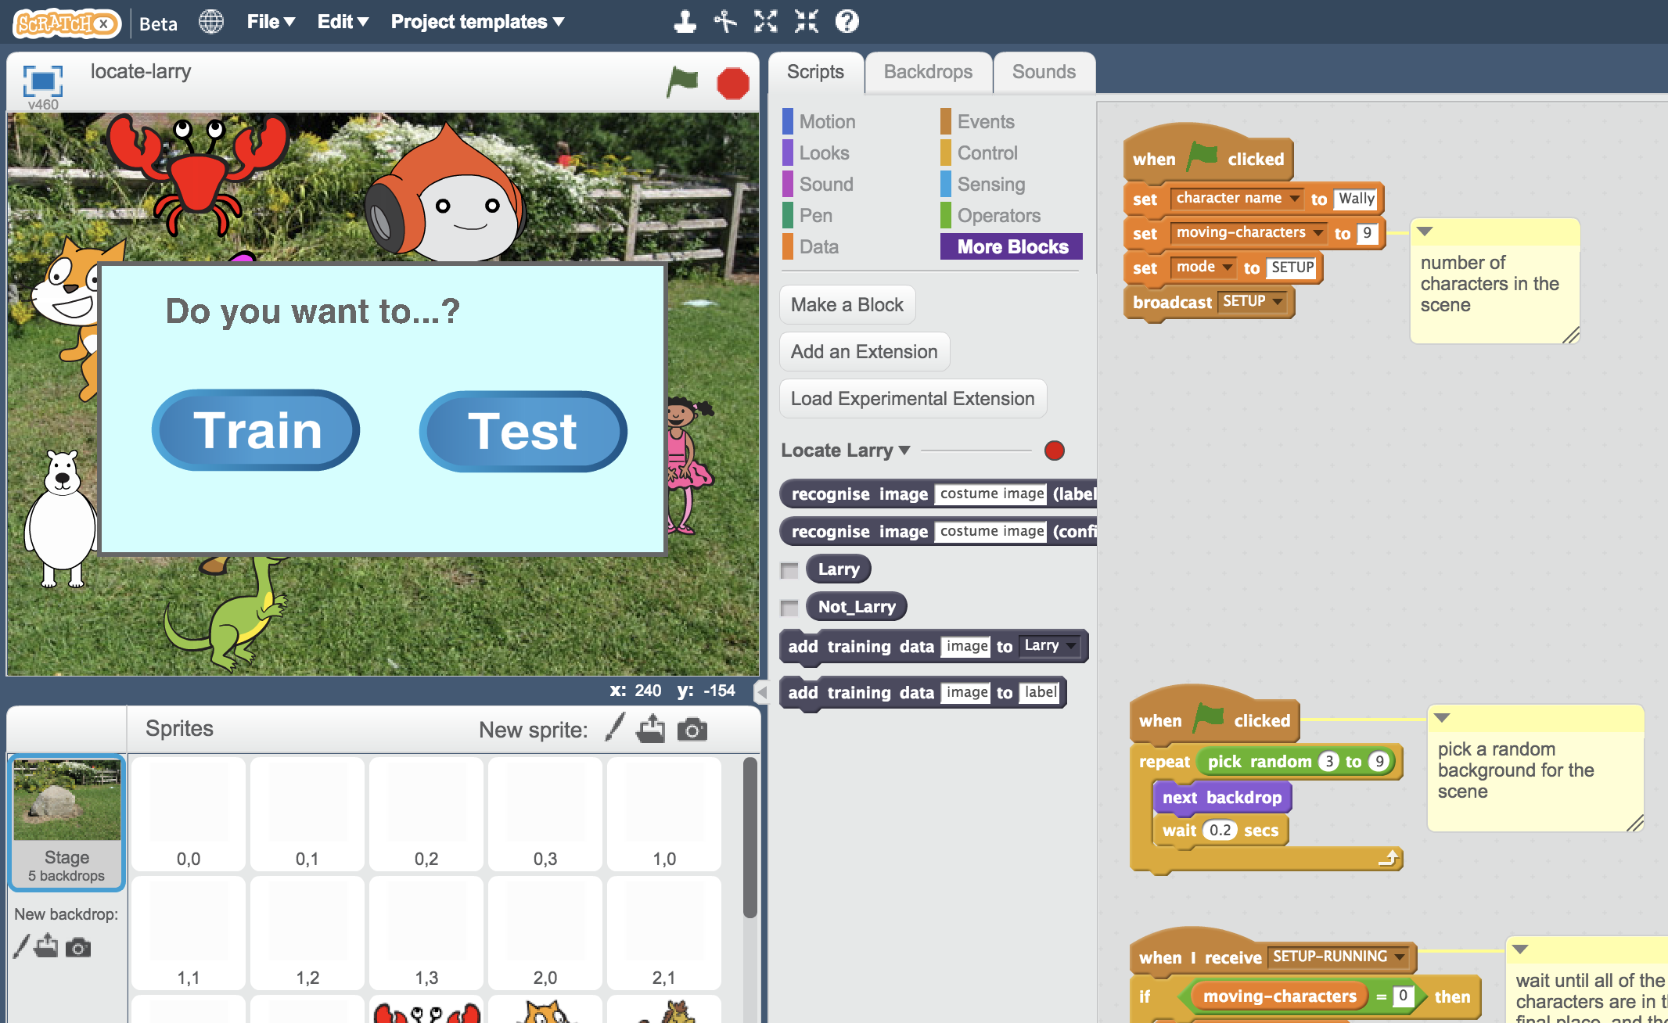

1. 選擇全螢幕，再點擊綠旗

Click on “full screen” and then click the Green Flag  
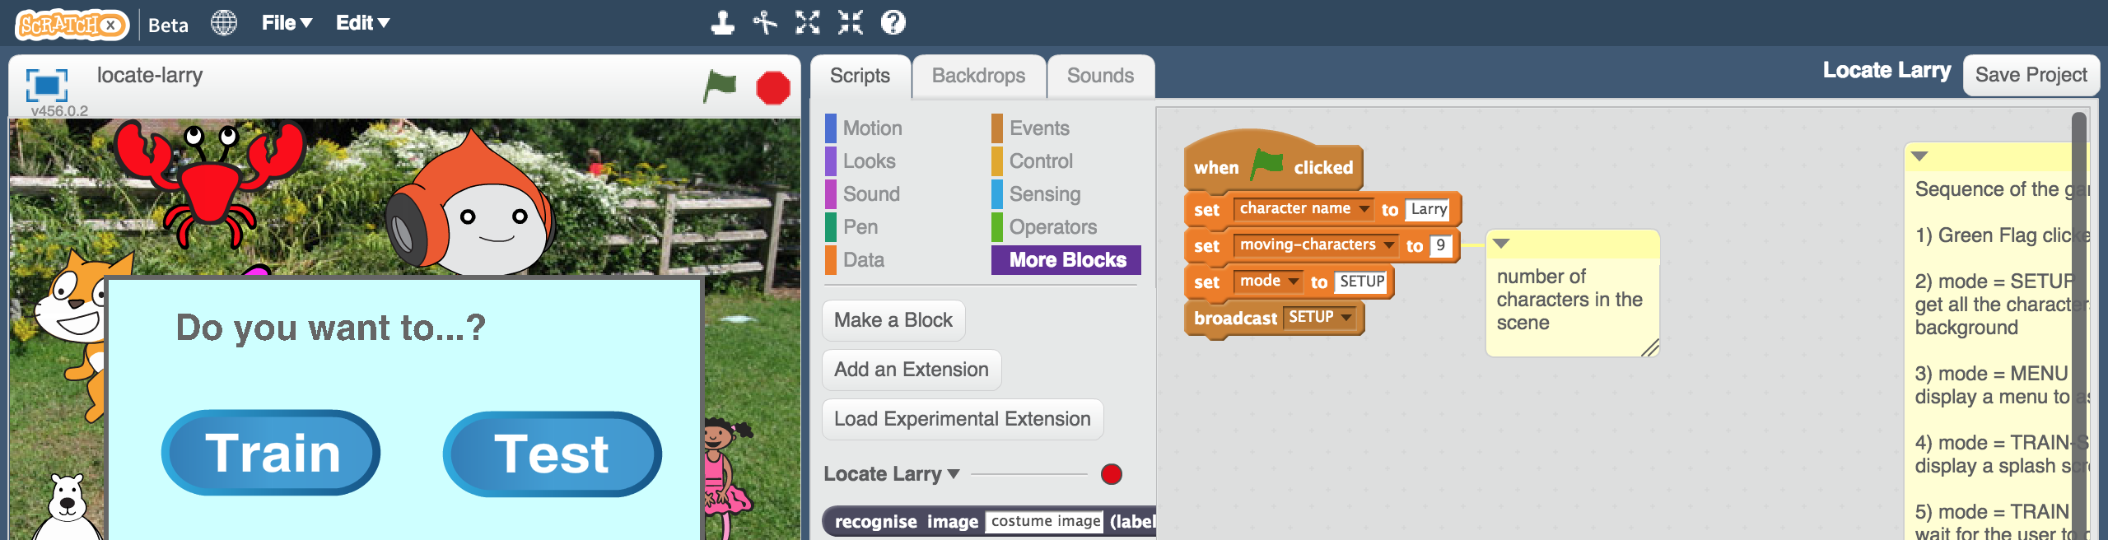

1. 電腦會隨機挑選一個背景，並弄亂所有角色（選擇任意大小、位置與造型），點選**Train**

The script will pick a random background, and shuffle the characters (choosing a random size, position and costume for them).   
Click “**Train**”  
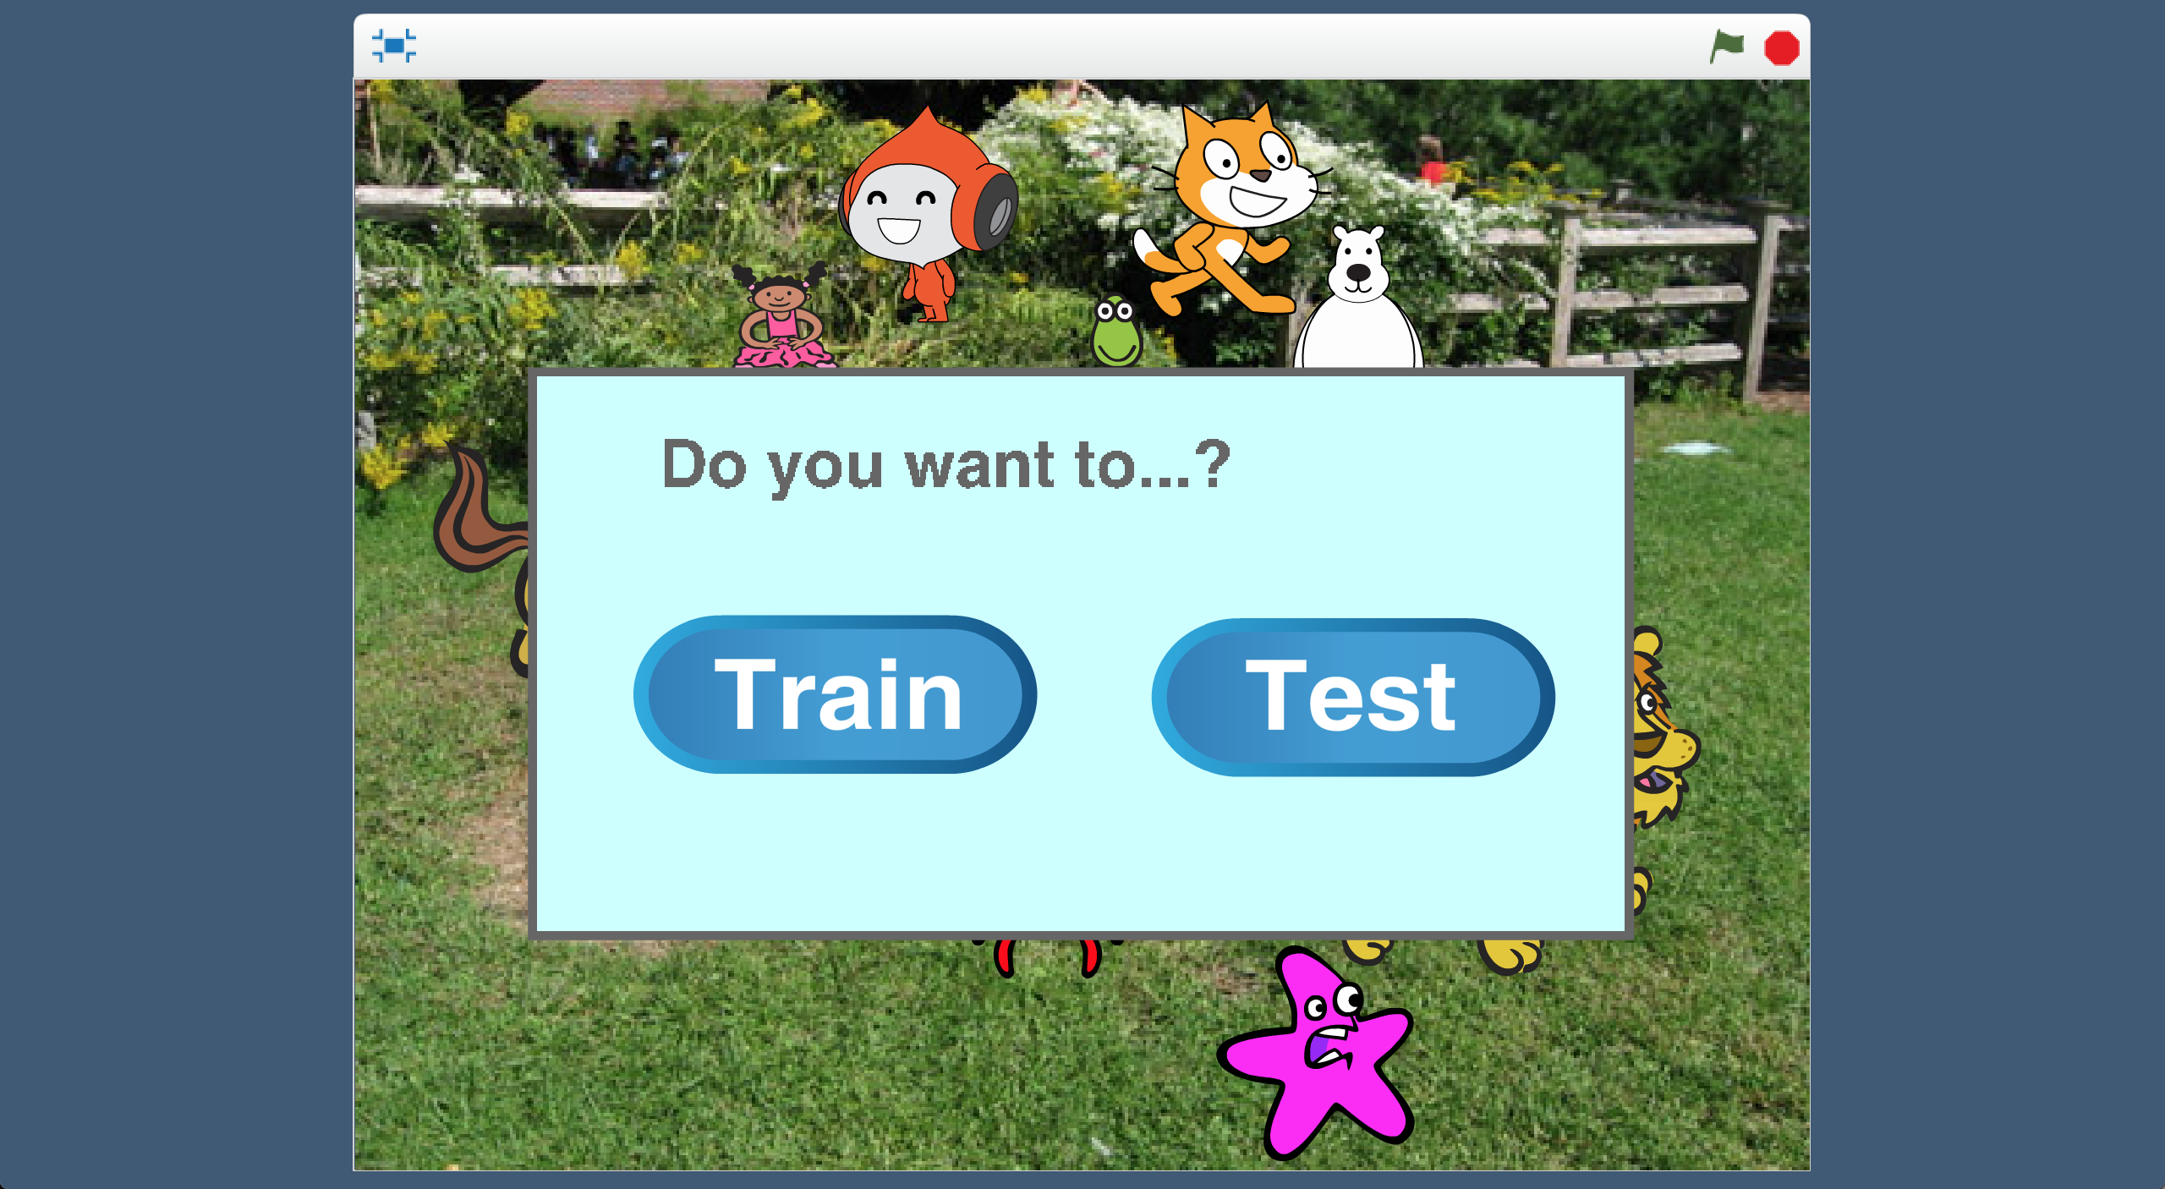  
點選**OK**  
Click “**OK**”

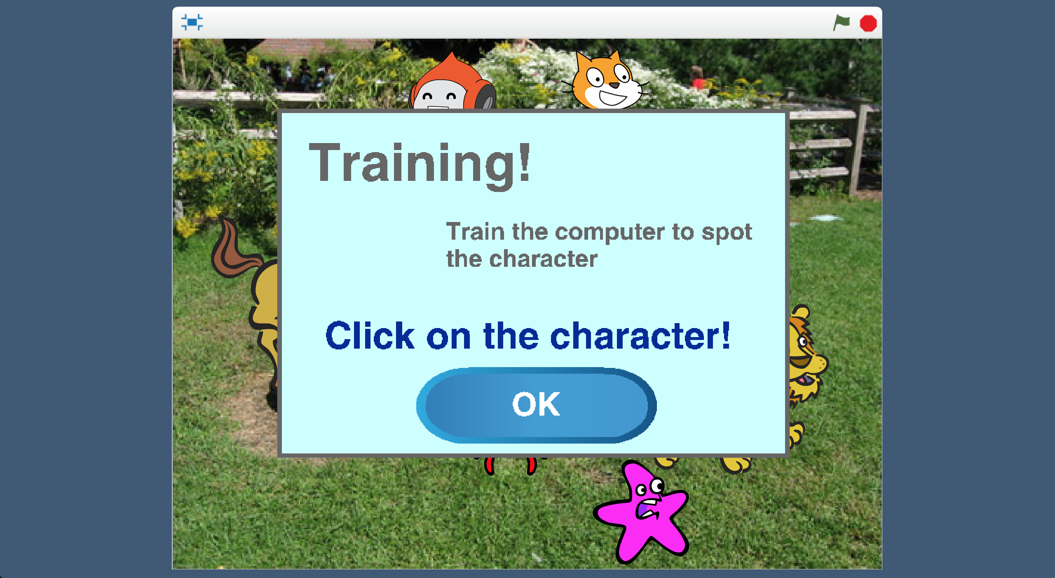

1. 點擊你一開始選擇的角色

*我們在訓練電腦如何找到你選的角色，因此點擊該角色會蒐集範例：角色模樣的範例*

Click on the character that you chose before  
*We’re training the computer how to find the character you chose – so clicking on it will collect an example of what they look like.*   
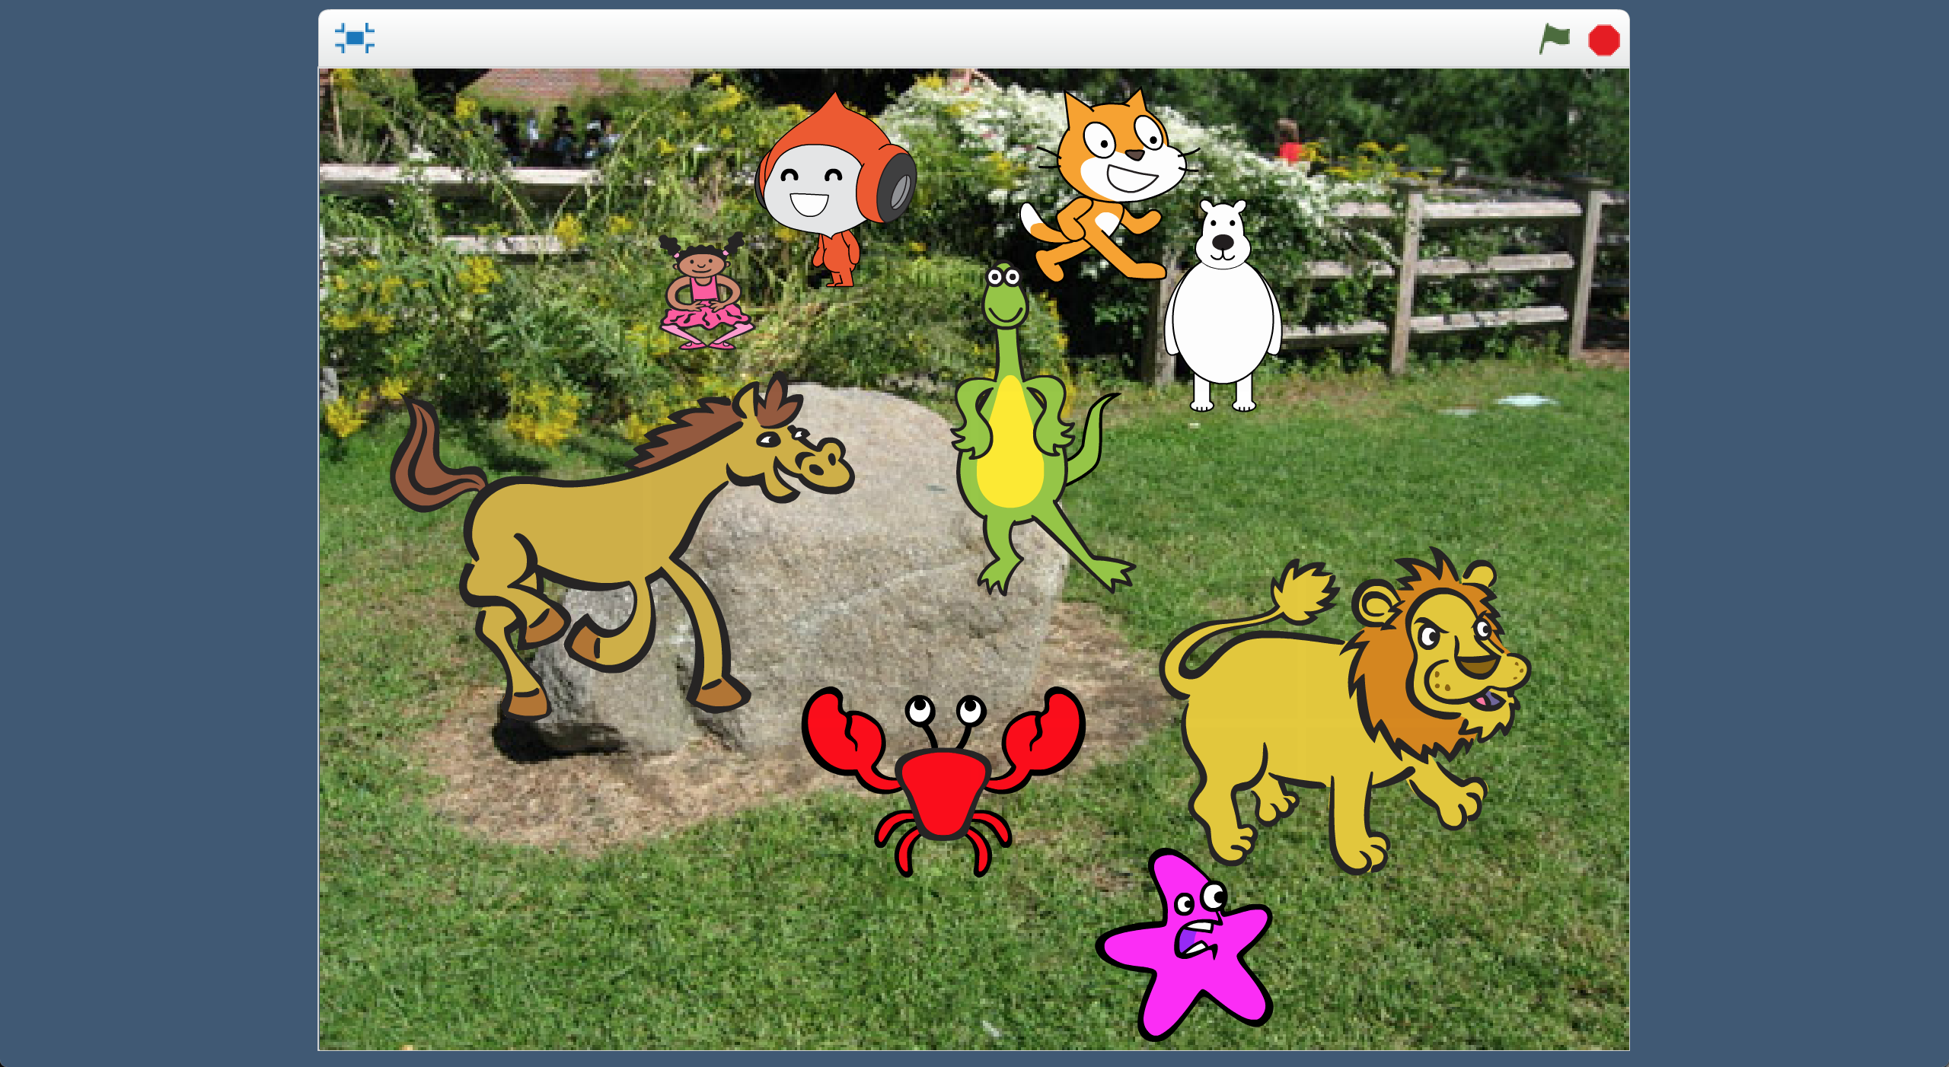

e.g. click here

1. 接下來你需要點選角色**沒有出現**的區域，點選OK

Next, you need to collect an area of the stage that **doesn’t** have your character. *Click “OK”*   
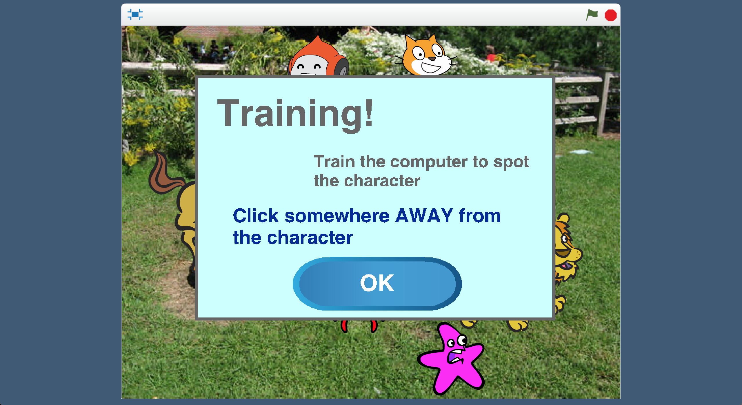

1. 點擊一個你所選擇的角色完全沒有出現的區域

Click any area that your character definitely isn’t in  
**

1. 回到訓練視窗（不要關閉Scratch視窗！）

點選**< Back to project**再點選**Train**按鈕

*你應該會看到從Scratch蒐集來的兩張訓練圖片*

Go back to the main training tool window. *(Leave Scratch open!)*  
Click “**< Back to project**” and then click the “**Train**” button.   
*You should see the two training images from Scratch*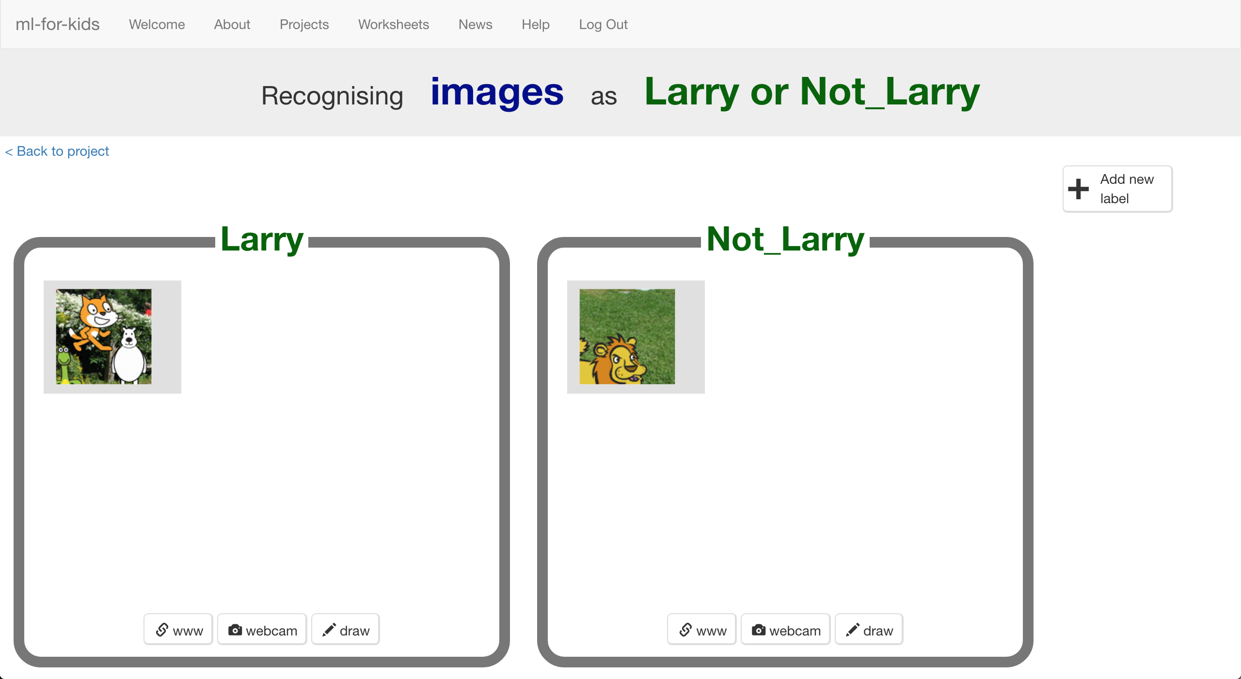

1. 回到Scratch視窗。

點擊綠旗重新開始，重複直到蒐集完**10組**範例

Go back to the Scratch window. Click the Green Flag and start again.  
*Repeat and collect* ***ten (pairs of)*** *examples.*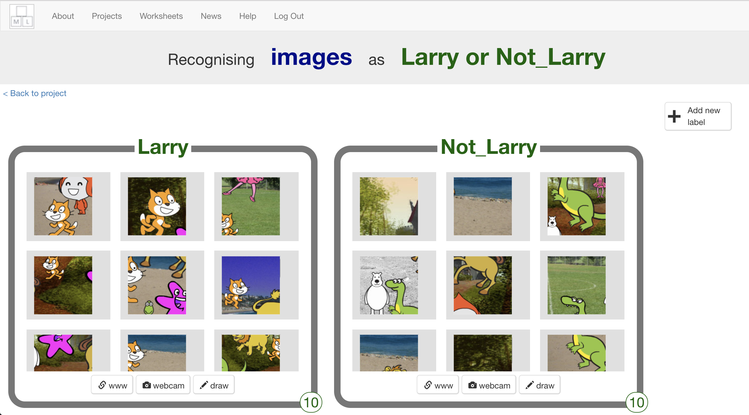

1. 存檔

*點選檔案 –> 儲存檔案*

Save your Scratch project   
*Click “****File****” -> “****Save project****”*

1. 點選“**< Back to project**”，再點選 “**Learn & Test**”

Click “**< Back to project**” and then click the “**Learn & Test**” button

1. 點選“**Train new machine learning model**”按鈕

*電腦會開始學習如何辨別你選擇的角色*

Click the “**Train new machine learning model**” button  
*The computer should start to learn how to recognise your character.*  
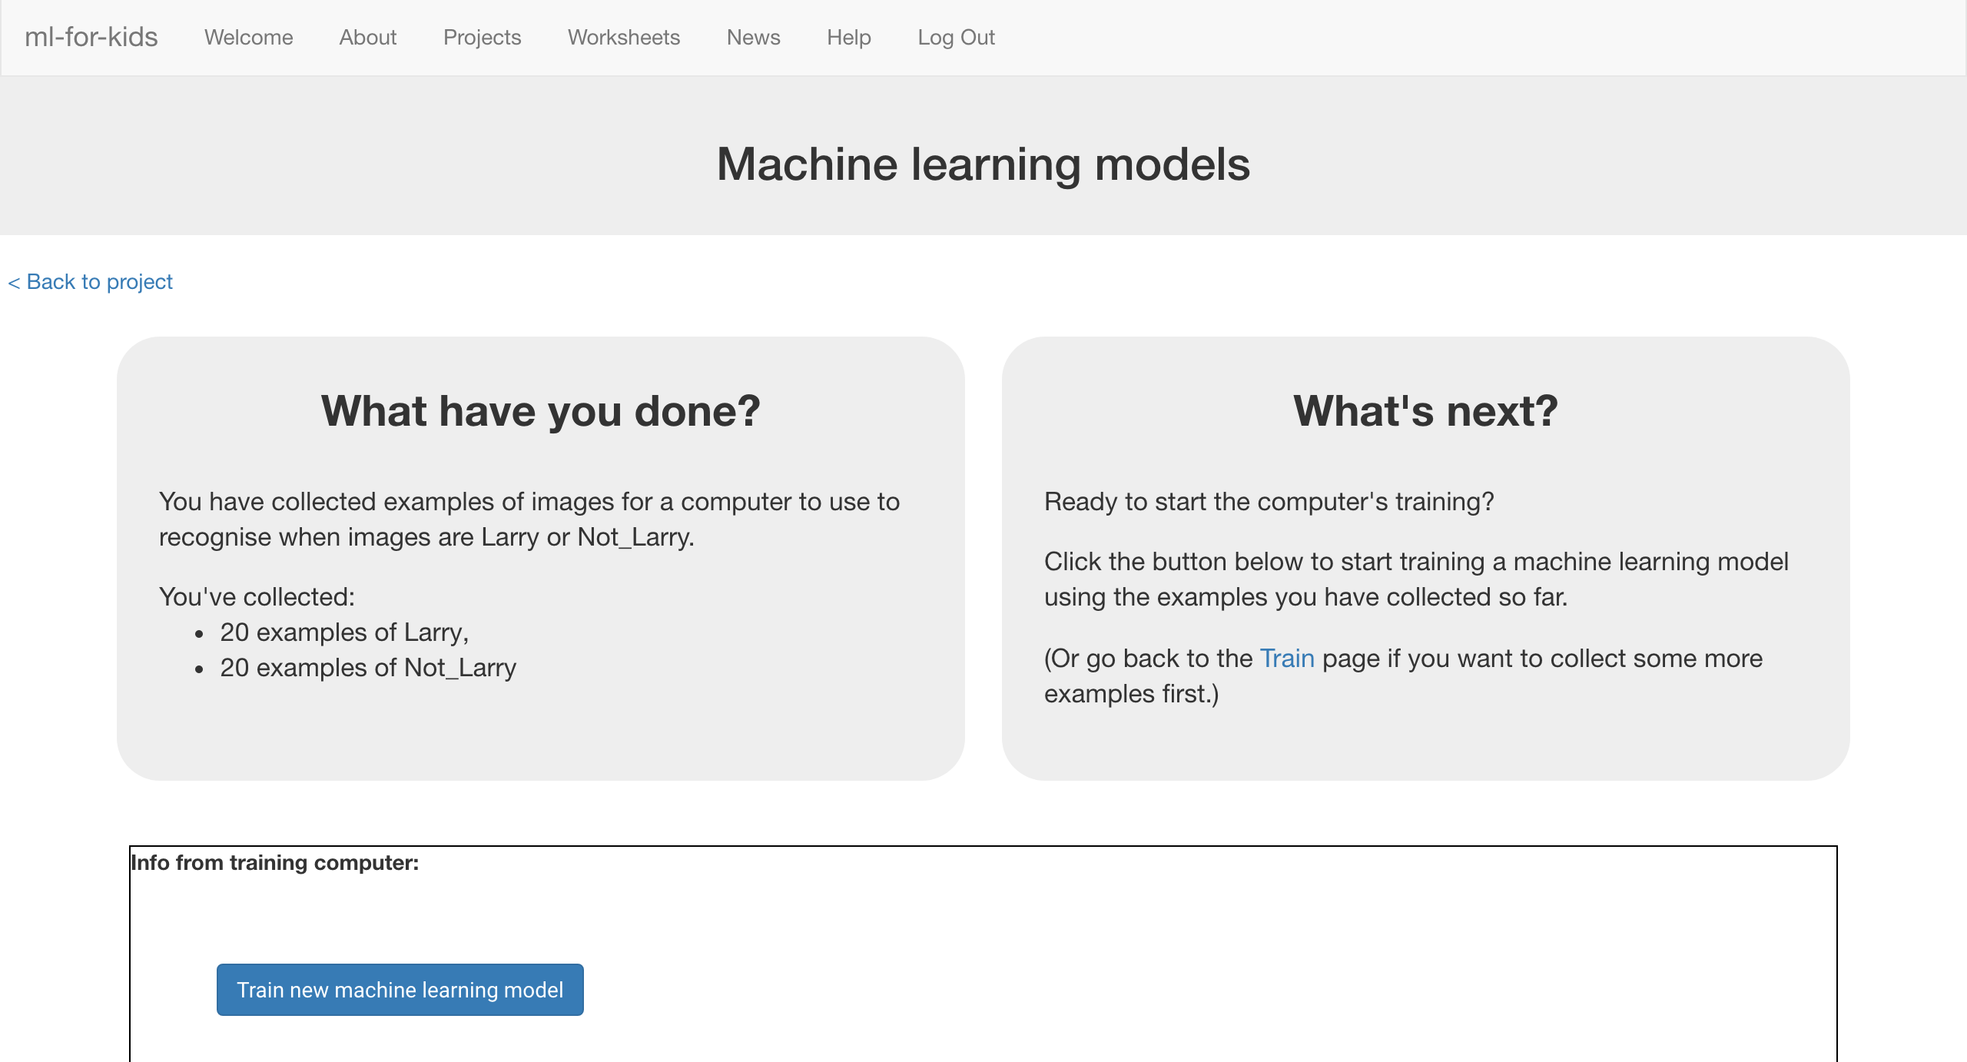

1. 回到Scratch視窗

*點選* ***< Back to project*** *->* ***Make*** *->* ***Scratch*** *->* ***Open in Scratch*** *->* ***File*** *->* ***Load Project***

Switch back to the Scratch window.   
*If you accidentally closed it, you can get back to it by doing this:  
* Click the “****< Back to project****” link  
* Click the “****Make****” button  
* Click the “****Scratch****” button, and then click the “****Open in Scratch****” button  
* Open the Scratch project you saved before, with “****File****” -> “****Load Project****”*

1. 點選**0,0**角色，找到積木組合區的**when I receive TEST-0,0**積木

*此段積木可能會在非常下面*

Click the “**0,0**” sprite, and find the “**when I receive TEST-0,0**” script  
*It will be at the very bottom. You might need to scroll down to it.*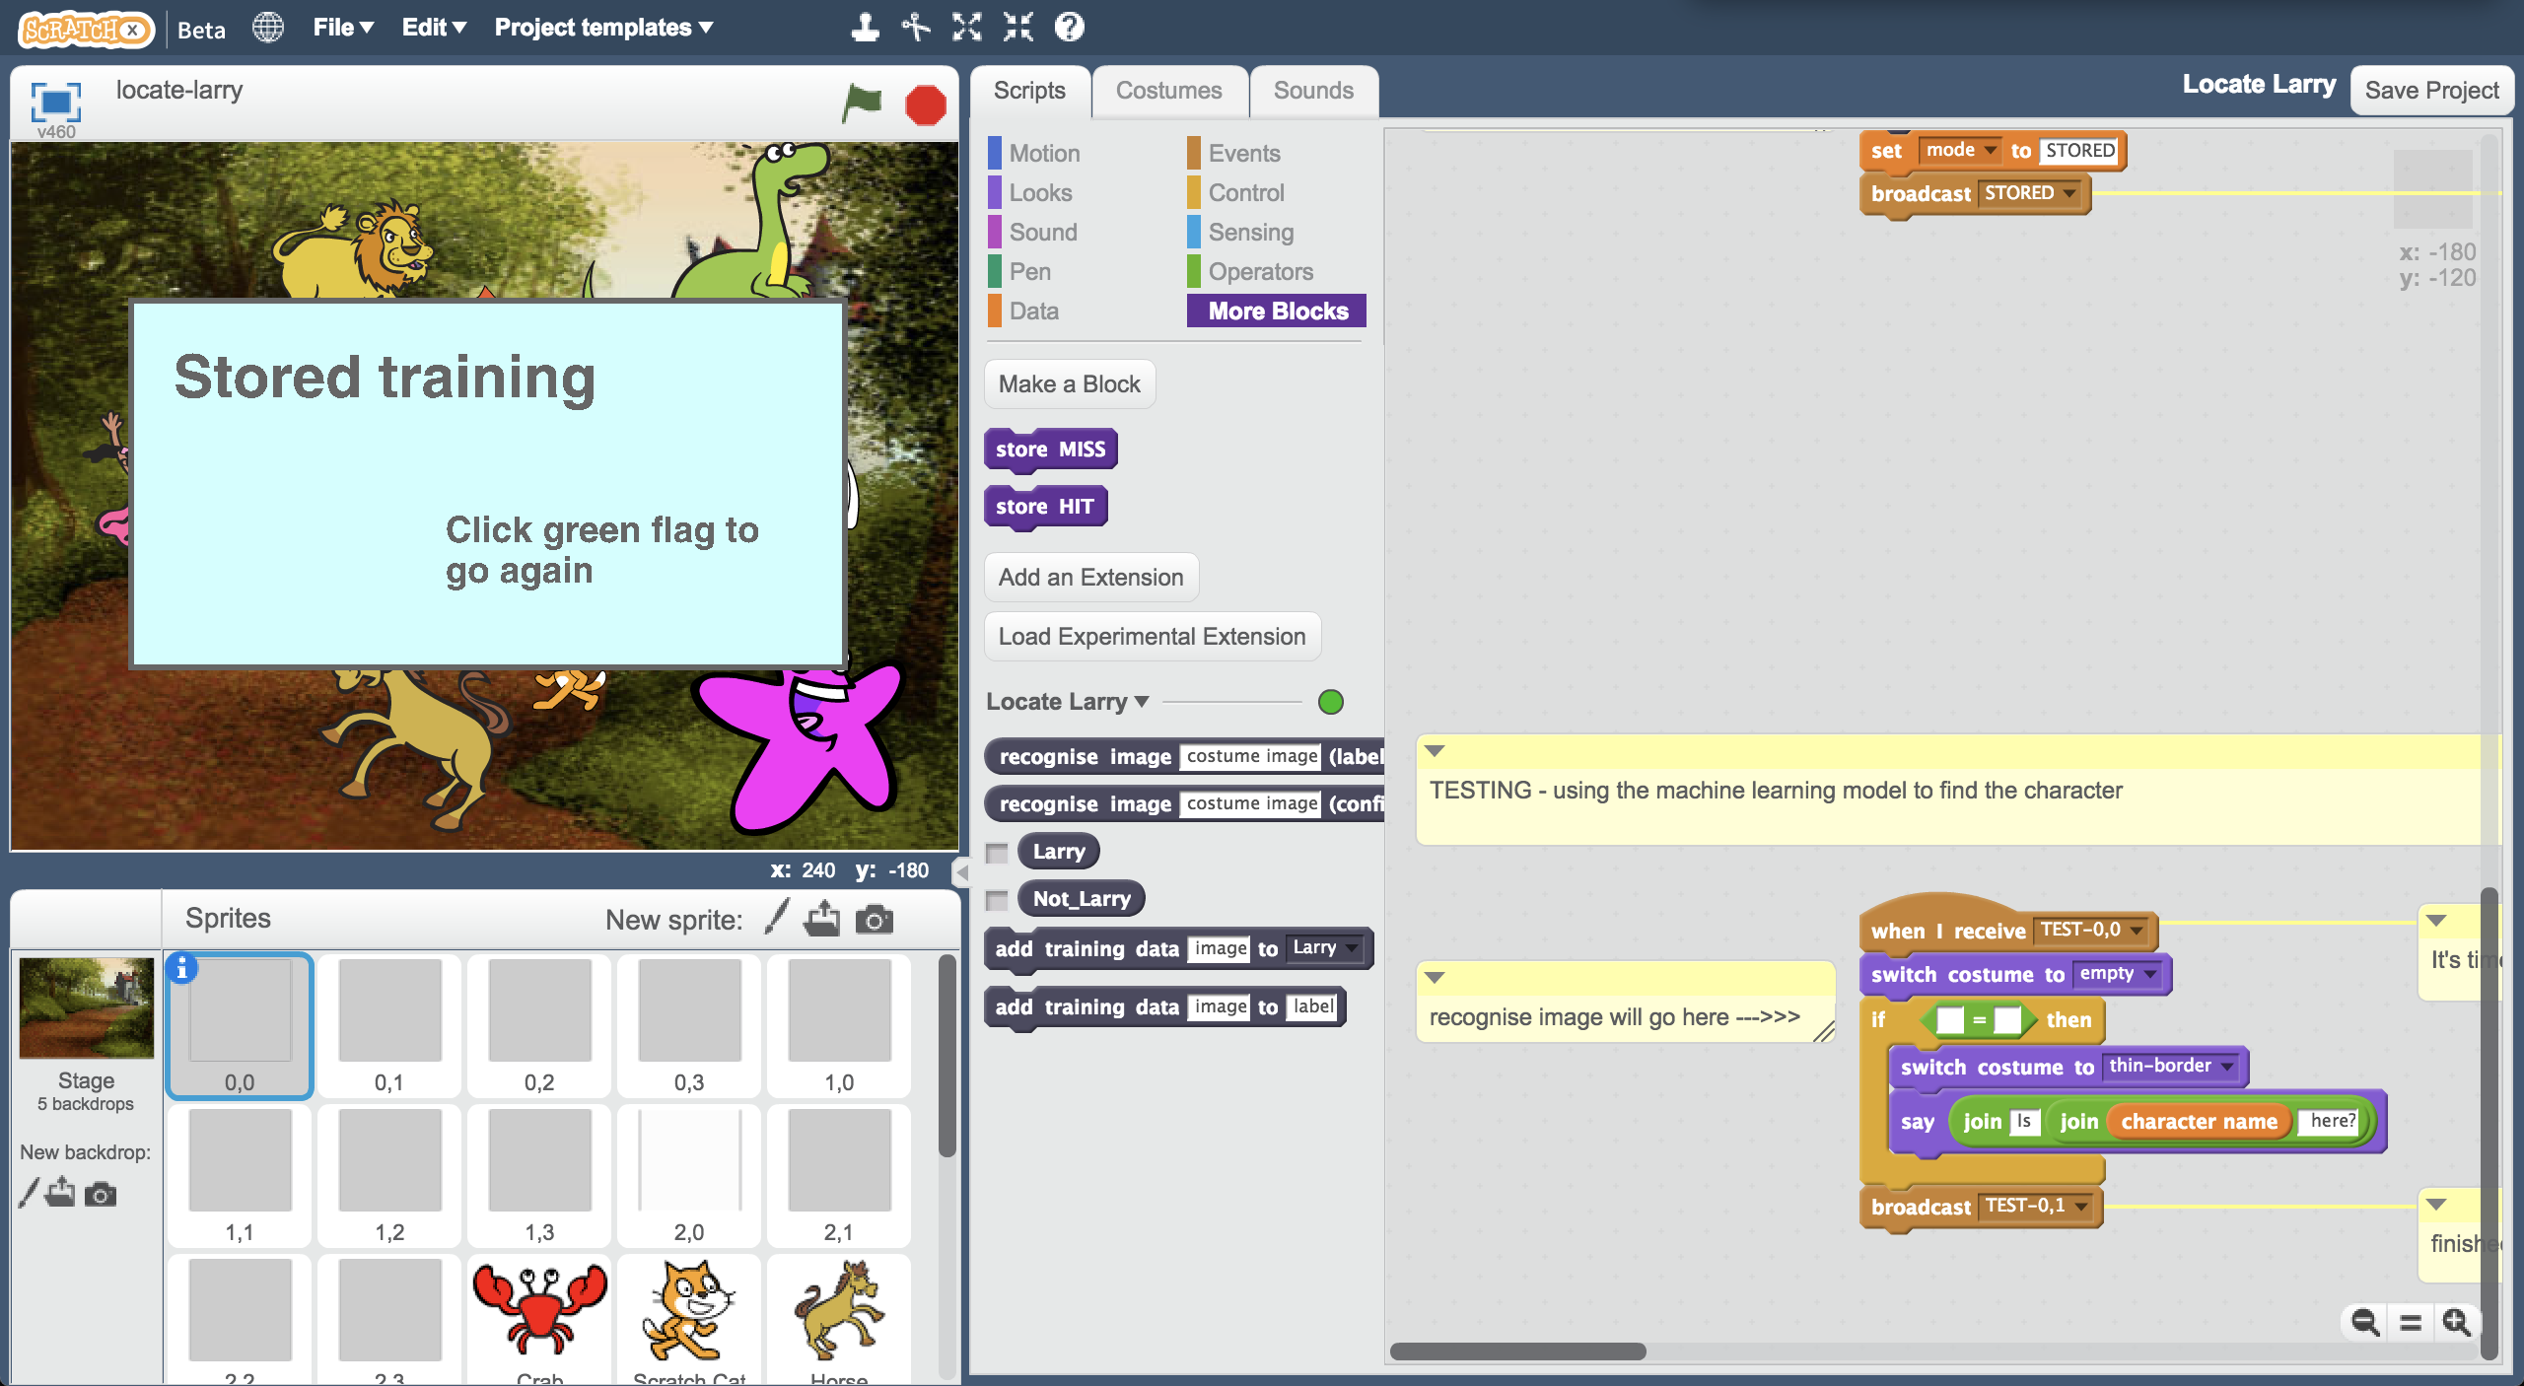

1. 拖曳積木更新程式碼（如下圖）

*你可以點開註解recognise image will go here，裡面會告訴你怎麼做，你需要加入recognise image、backdrop image和Larry積木*

Update the script to look like this  
*The comment “recognise image will go here” is there to help.   
You need to add the “recognise image”, “backdrop image” and “Larry” blocks.*   
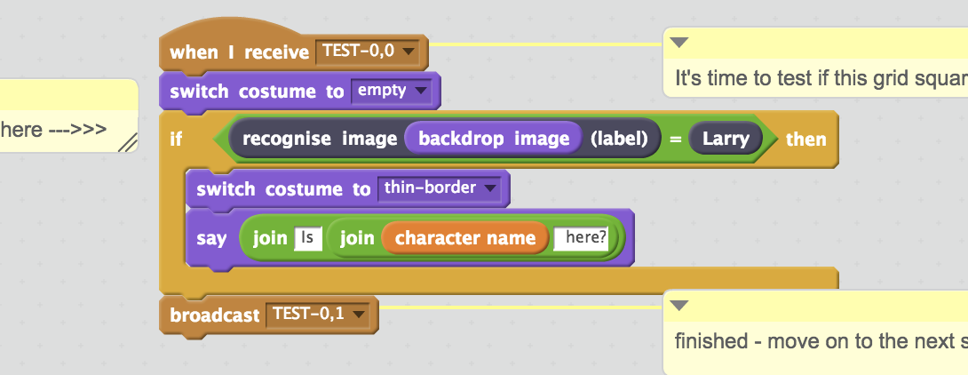

1. 點擊角色0,1，並重複上面的步驟

*你需要加入三個積木：recognise image、backdrop image和Larry積木*

Click on the “0,1” sprite, and do the same again  
*As before, there are three blocks you need to add:   
 “recognise image”, “backdrop image” and “Larry”*  
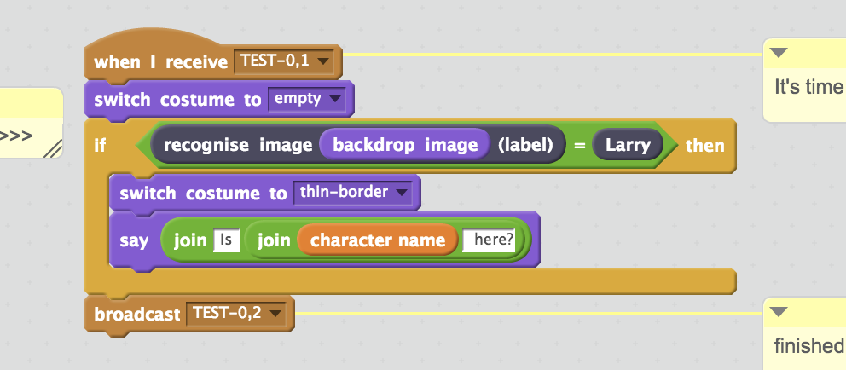

1. 角色0,2 0,3 1,0 1,1 1,2 1,3 2,0 2,1 2,2 2,3也都要做同樣的事情

請再次確認12個角色都有被加入新積木！

Do that again for all the other grid square sprites:  
0,2 0,3 1,0 1,1 1,2 1,3 2,0 2,1 2,2 2,3  
  
Make sure you do all twelve sprites that look like grey squares!

1. 測試時間到！點選全螢幕，再點擊綠旗

It’s time to test!  
*Click the “full-screen” button, and then click the Green Flag.*   
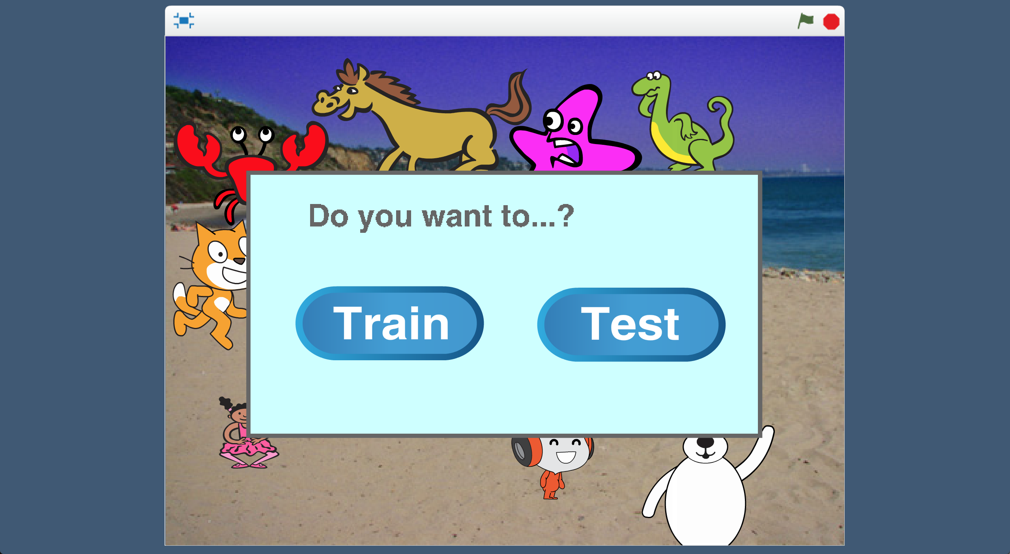

1. 點選**Test**

Click “**Test**”  


1. 有順利執行嗎？

*多試幾次，觀察電腦尋找角色的正確率有多高*

Did it work?  
*Try it a couple of times and see how good it is at finding your character.*

1. 如果對結果不滿意，點擊綠旗，再選擇Train蒐集更多範例。

*要使用新範例，****你需要重新訓練一個機器學習模型****。*

If it’s not getting it right, click the Green Flag and then click Train a few times to collect more examples. *You* ***need to train a new machine learning model again*** *to use the new examples.   
  
  
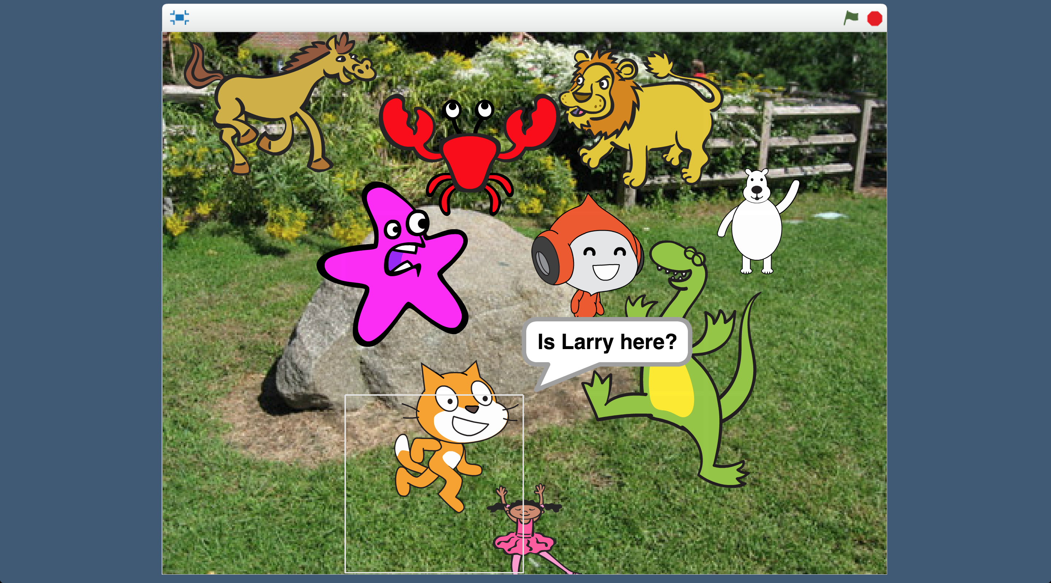*

**完成什麼？**

**What have you done?**

你訓練了一個機器學習模型來辨識一張照片中某個特定角色。

You’ve trained a machine learning model to be able to recognise a character in a picture.

不僅僅想知道照片中是否有這個角色，你還想知道角色在哪裡。為了達成這個目標，我們將照片切成12份，接著使用機器學習模型個別確認每一小塊照片

You don’t just want to know if the character is in the picture, but where in the picture they are. To do this, the picture was cut up into twelve squares, and you used the machine learning model to check each of the twelve squares individually.

**你知道嗎？**

**Did you know?**

你在Scratch中所做的常被用在尋找照片中的某項事物

What you’ve made in Scratch is a common approach for finding things in pictures.

**路標辨識**

**Street sign Captchas**

你是否曾經在登入網站時被要求

完成這種測試？點擊含有路標的

方格是常見的一種測試。

Have you ever been asked to complete a “captcha” as part of logging into a website? Clicking on squares in a photo that contain street signs is a common one.

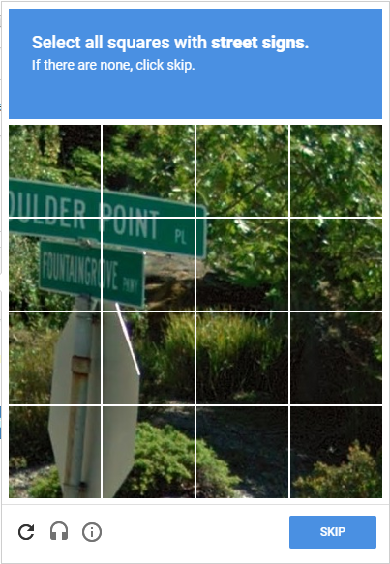

在你證明自己是個人類的同時，

你也在幫助訓練一個機器學習模型辨別路標，這和你在專案中做的事情很類似。

As well as proving that you are a human, this is very similar to what you made in this project: you are helping to train a machine learning model to recognise and find street signs.

你覺得這對研發自駕車有幫助嗎？

Do you think this could be useful to help with the development of self-driving cars?

**快速了解乾旱時期的用水情況**

**Quickly understanding water usage in times of drought**

2015年，在加州陷入乾旱造成的緊急情況時，有個機器學習模型被用來尋找草地、游泳池以及其他會影響用水的因素。

In 2015, during a state of emergency caused by a drought in California, a machine learning model was used to find lawns, swimming pools, & other features that affect water usage.

將整個州的衛星影像切成小等份，每個等份就能個別分類。重新組合後就可以迅速了解乾旱對整個州用水量的影響。

By cutting the satellite images for the whole state into small squares, each one could be individually classified. Combining this with a map meant they could quickly understand the impact on water usage across the state.